EXPERIMENT-2

2. Create a simple cloud software application for Flight Reservation System using any Cloud Service Provider to demonstrate SaaS

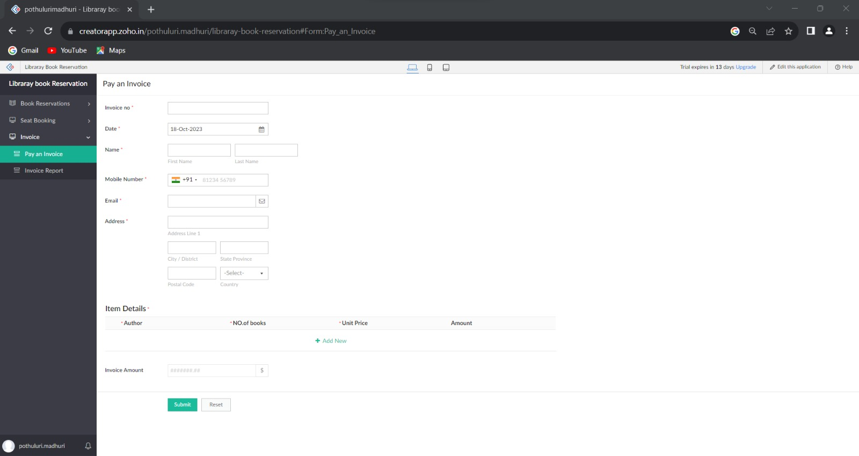





NAME:V.LOKESH

REG NO: 192210291